REPORT ON SMART AGRICULTURE BASED ON IoT.

1.INTRODUCTION

1.1) OVERVIEW

Smart farming is a capital-intensive and hi-tech system of growing food cleanly and sustainable for the masses. It is the application of modern ICT (Information and Communication Technologies) into agriculture.

In IoT-based smart farming, a system is built for monitoring the crop field with the help of sensors (light, humidity, temperature, soil moisture, etc.) and automating the irrigation system. The farmers can monitor the field conditions from anywhere. IoT-based smart farming is highly efficient when compared with the conventional approach.

1.2) PURPOSE

The global population is predicted to touch 9.6 billion by 2050 – this poses a big problem for the agriculture industry. Despite combating challenges like extreme weather conditions, rising climate change, and farming’s environmental impact, the demand for more food has to be met. To meet these increasing needs, agriculture has to turn to new technology. New smart farming applications based on IoT technologies will enable the agriculture industry to reduce waste and enhance productivity from optimizing fertilizer use to increasing the efficiency of farm vehicles’ routes.

In terms of environmental issues, IoT-based smart farming can provide great benefits including more efficient water usage, or optimization of inputs and treatments. Now, let’s discuss the major applications of IoT-based smart farming that are revolutionizing agriculture.

2. LITERATURE SURVEY

2.1) EXISTING PROBLEM

Horticulture is the foundation of our Nation. In long time past days agriculturists used to figure the ripeness of soil and influenced presumptions to develop which to kind of product. They didn't think about the dampness, level of water and especially climate condition which horrible an agriculturist more. They utilize pesticides in view of a few suspicions which made lead a genuine impact to the yield if the supposition isn't right .The profitability relies upon the last phase of the harvest on which agriculturist depends.

2.2) PROPOSED SOLUTION

To improve the efficiency of the product there by supporting both rancher and country we need to utilize the innovation which appraises the nature of harvest and giving recommendations. The Internet of things (IOT) is revamping the agribusiness engaging the farmers by the broad assortment of techniques, for instance, accuracy and conservative cultivation to go up against challenges in the field. IOT advancement aids in social affair information on conditions like atmosphere, temperature and productivity of soil, harvest web watching engages area of weed, level of water, bug acknowledgment, animal interference in to the field, alter improvement, cultivation . IOT utilize farmers to get related with his residence from wherever and at whatever point. Remote sensor frameworks are used for checking the farm conditions and little scale controllers are used to control and robotize the property shapes

3. THEORETICAL ANALYSIS

3.1) BLOCK DIAGRAM

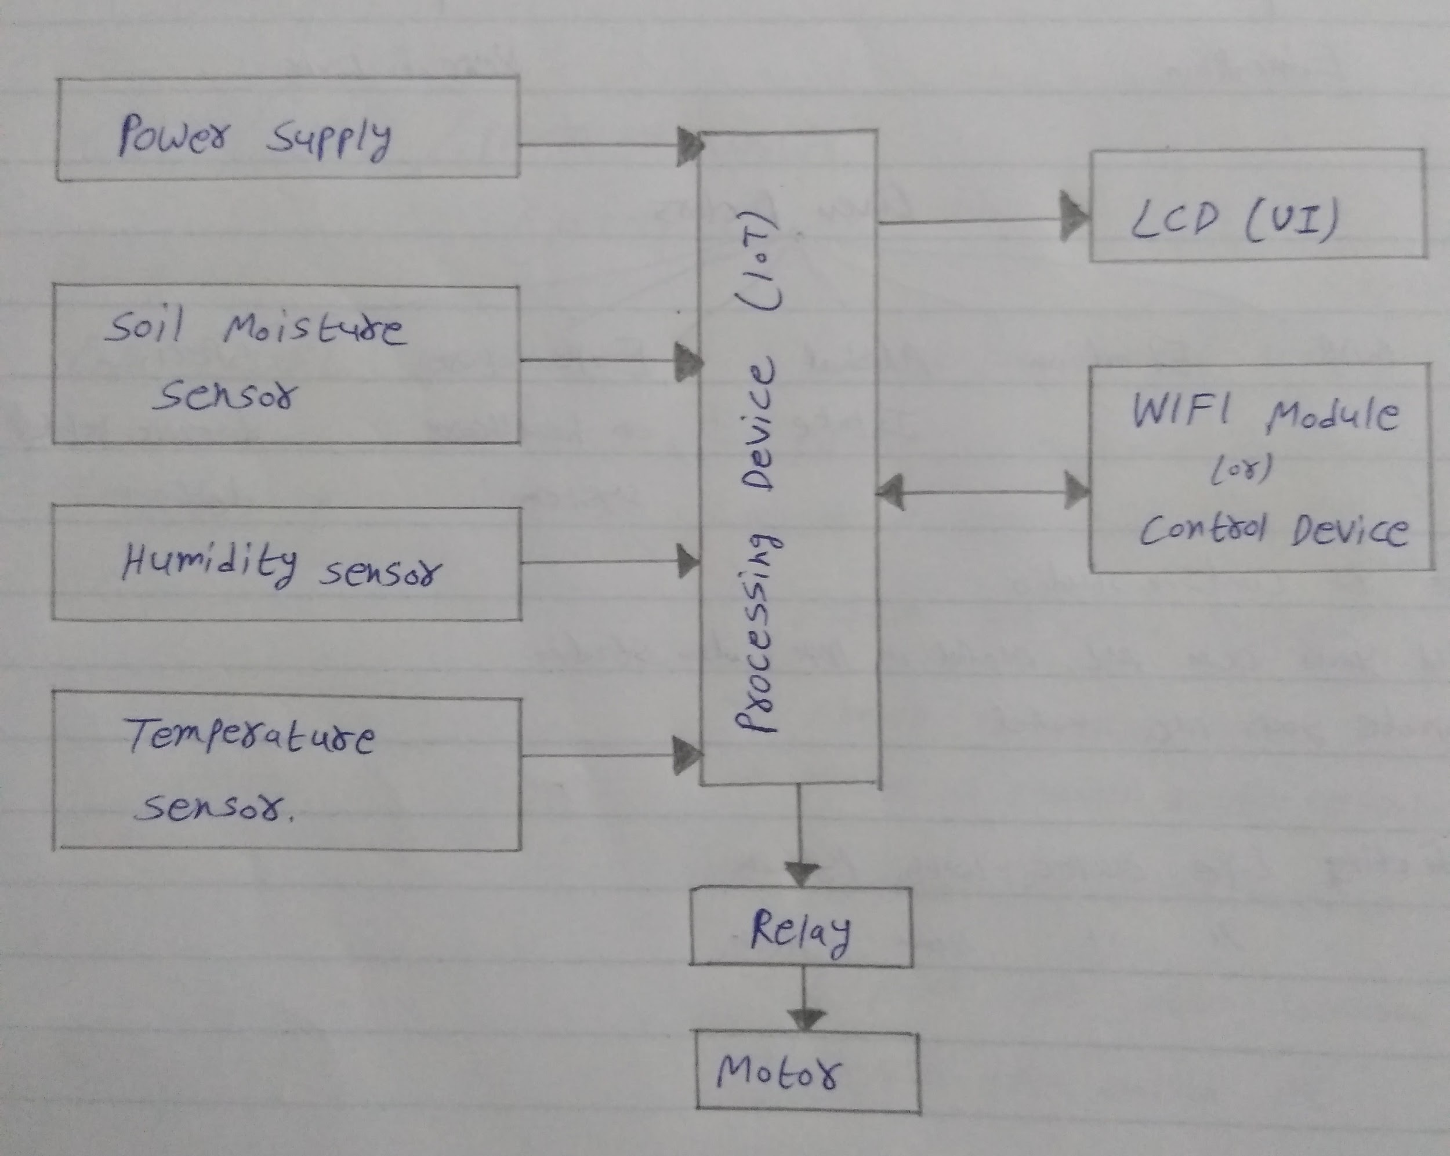

3.2) HARDWARE/SOFTWARE DESIGNING.

Hardware to be used:-

TEMPERATURE SENSOR-

Those LM35 may be an incorporated information preparing sensor that might a chance to be used to figure temperature for an electrical yield proportional of the temperature (in °C). It might quantify temperature additional faultlessly over a utilizing a indoor controller.

MOISTURE SENSOR

Soil sensor may be a sensor which faculties those wetness material of the soil. That sensor need just as the plain and the propelled yield. The propelled yield will be created and the plain yield limit might a chance to be fluctuated. It takes a shot on the example about open Also short crazy. That yield may be secondary or low demonstrated toward the headed. During those side of the point when the mud may be dry, those current won't experience it Along these lines it will clear out for Concerning illustration open circuit.

HUMIDITY SENSOR

HR 202 Humidity is coordinated circuit sensors that can be utilized to gauge the nearness of water in arrive. The HR202 is another sort of stickiness touchy resistor produced using natural macromolecule materials, it can be utilized as a part of events like: clinics, stockpiling, workshop, material industry and so on. The Stickiness sensor with its yield Relative to the temperature (in RH %). The operational temperature extend is from20-95%RH.

4. EXPERIMENTAL INVESTIGATION.

The received outputs from conducted experiments are.

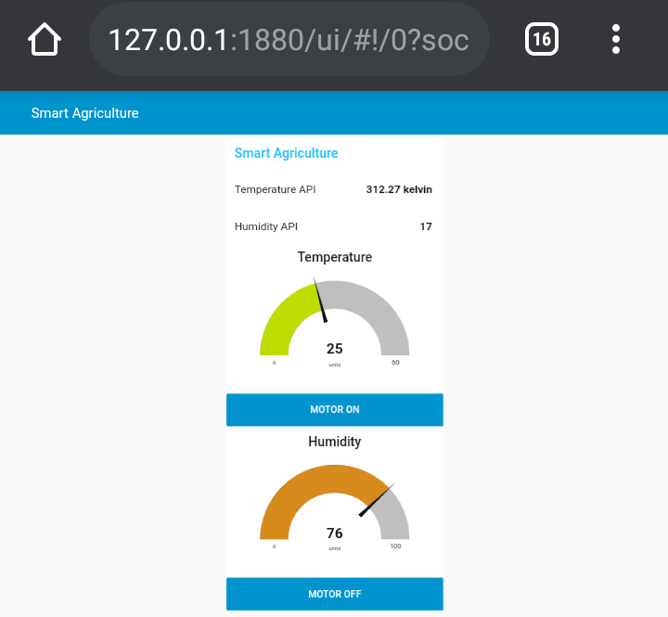

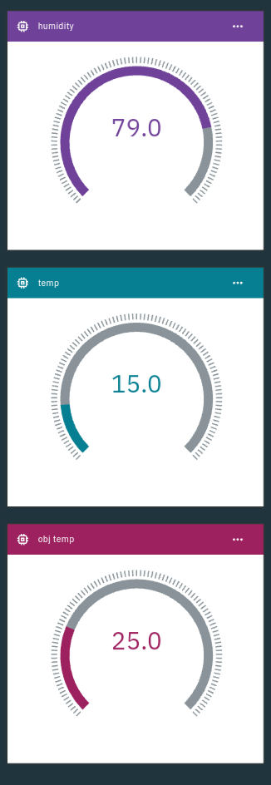

5. FLOWCHART

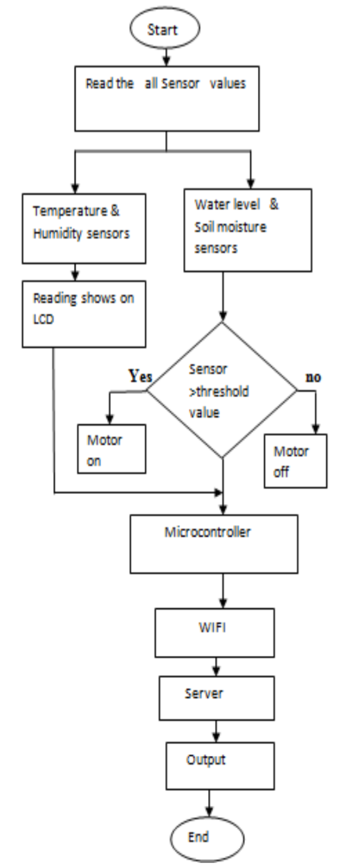

6. RESULT

The yield appeared beneath signifies the temperature, soil dampness state and the gate crasher discovery. The nextoutcome is the yield as of the Android purpose that is produced in the cell phone. It decides the temperature, stickiness, dampness as well as the interloper discovery. The yield appeared beneath means the temperature, soil dampness state with the gate crasher identification. The second outcome is the yield from the Android purpose that is produced in the cell phone. It decides the temperature, dampness, dampness with the gate crasher location.

7. ADVANTAGES:

*Significantly increased yield per acre, per person and per dollar relative to extensive farming

*Food becomes more affordable to the consumer as it costs less to produce.

*The preservation of existing areas of woodland and rain forest habitats (and the ecosystems and other sustainable economies that these may harbour), which would need to be felled for extensive farming methods in the same geographical location. This also leads to a reduction in anthropomorphic CO2 generation (resulting from removal of the sequestration afforded by woodlands and rain forests)

DISADVANTAGES:

*Lack of practical knowledge the farmers cant handle the machines

*While the cost of maintenance is very high.

*The overuse of machines may lead to environmental damage.

8.APPLICATIONS

**Precision Farming**

Also known as precision agriculture, precision farming can be thought of as anything that makes farming practice more controlled and accurate when it comes to raising livestock and growing crops. In this approach of farm management, a key component is the use of IT and various items like sensors, control systems, robotics, autonomous vehicles, automated hardware, variable rate technology, and so on.

The adoption of access to high-speed internet, mobile devices, and reliable, low-cost satellites (for imagery and positioning) by the manufacturer are a few key technologies characterizing the precision agriculture trend.

Precision agriculture is one of the most famous applications of IoT in the agricultural sector and numerous organizations are leveraging this technique around the world. CropMetrics is a precision agriculture organization focused on ultra-modern agronomic solutions while specializing in the management of precision irrigation.

9. CONCLUSION

Therefore, the paper proposes a thought of consolidating the most recent innovation into the agrarian field to turn the customary techniques for water system to current strategies in this way making simple profitable and temperate trimming. Some degree of mechanization is presented empowering the idea of observing the field and the product conditions inside some long-separate extents utilizing cloud administrations. The points of interest like water sparing and work sparing are started utilizing sensors that work consequently as they are modified. This idea of modernization of farming is straightforward, reasonable and operable. As relying upon these parameter esteems rancher can without much of a stretch choose which fungicides and pesticides are utilized for enhancing crop creation.

10. FUTURE SCOPE

IoT agricultural applications are making it possible for ranchers and farmers to collect meaningful data. Large landowners and small farmers must understand the potential of IoT market for agriculture by installing smart technologies to increase competitiveness and sustainability in their productions. With the population growing rapidly, the demand can be successfully met if the ranchers, as well as small farmers, implement agricultural IoT solutions in a prosperous manner.

With a future of efficient, data-driven, highly-precise farming methods, it is definitely safe to call this type of farming smart. We can expect IoT will forever change the way we grow food.

11. BIBLIOGRAPHY

1. k.lakshmisudha, swathi hegde, neha cole, shruti iyer, " good particularity most stationed cultivation spinning sensors", state-of-the-art weekly going from microcomputer applications (0975-8887), number 146-no.11, july 2011

2. nikesh gondchawar, dr. r.complexion.kawitkar, "iot based agriculture", all-embracing almanac consisting of contemporary analysis smart minicomputer additionally conversation planning (ijarcce), vol.5, affair 6, june 2016. Overall Journal on Recent and Innovation Trends in Computing andCommunication ISSN: 2321-8169 Volume: 5 Issue: 2 177 – 1813. M.K.Gayatri,J.Jayasakthi,Dr.G.S.Anandhamala, "Giving Smart Agriculture Solutions to Farmers for Better Yielding Using IoT", IEEE International Conference on Technological Innovations in ICT for Agriculture and Rural

4. Lustiness. r. nandurkar, slant. r. thool, r. tumor. thool, "plan together with situation coming from rigor horticulture technique executing trans-missions sensor network", ieee world consultation toward telemechanics, regulate, intensity also wiring (aces), 2014. Development (TIAR 2015).

5. Paparao Nalajala, D. Hemanth Kumar, P.Ramesh and Bhavana Godavarthi, 2017. Design and Implementation of Modern Automated Real Time Monitoring System for Agriculture using Internet of Things (IoT). Journal of Engineering and Applied Sciences, 12: 9389-9393.

6. Joaquín Gutiérrez, Juan Francisco Villa-Medina, Alejandra Nieto-Garibay, and Miguel Ángel PortaGándara, "Computerized Irrigation System Using a Wireless Sensor Network and GPRS Module", IEEE Transactions on Instrumentation andMeasurements, 0018-9456,2013

7. Paparao Nalajala, P Sambasiva Rao, YSangeetha, Ootla Balaji, K Navya,” Design of a Smart Mobile Case Framework Based on the Internet of Things”, Advances in Intelligent Systems and Computing,Volume 815, Pp. 657-666, 2019.

**APPENDIX.**

1. **Source code.**[**source code for smart Agriculture based on IoT**](https://github.com/SmartPracticeschool/llSPS-INT-838-Smart-Agriculture-system-based-on-IoT/blob/master/IoT%20python%20code.py)
2. **Flows**[**json node-red flows**](https://github.com/SmartPracticeschool/llSPS-INT-838-Smart-Agriculture-system-based-on-IoT/blob/master/flows%20(2).json)